The Sorry Cycle in Judges (ex. Judges 2:13-18)

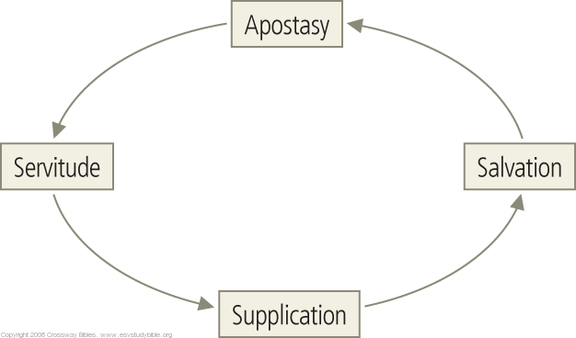

Question: How can Israel both not be like the nations and influence the nations? How does the conquest further God’s purpose to bless the nations through Israel?

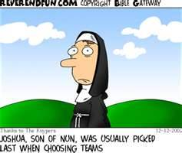

Old Testament Core Seminar

Class 9: Joshua & Judges

C.A.S.K.E.T. – Where are we in the Story???

Joshua - recording the fulfillment of God’s promise to give Israel the land of Canaan

Presence:____________________________________________________________________________________
Place:_______________________________________________________________________________________
People:_____________________________________________________________________________________
Purpose:____________________________________________________________________________________

Outline of Joshua

1-4 | Crossing into the Promised Land
5-12 | Taking the Promised Land
13-21 | Dividing the Promised Land
22-24 | Serving the Lord in the Promised Land

Compare and Contrast: Joshua and Jesus

יְהוֹשׁוּעַ - Joshua means “the Lord saves,” or “may the Lord save.”

“The Old Greek Version (Septuagint; LXX) render the name as Ἰησοῦς (which is the same as the New Testament name for Jesus…)” David Howard, Jr An Introduction to the Old Testament Historical Books

“She [Mary] will bear a son, and you shall call his name Jesus, for he will save his people from their sins." (Matthew 1:21 ESV)

God

Joshua
x x x x
x x
x x x x
x x x
Israel

Q. Using the information above, how is Jesus similar to and different from Joshua? How might this influence the way you relate to Christ?

Conquest: Jericho, Ai and all the rest…

Group Project: What do we learn about the conquest from the following verses?
Genesis 15:16

Leviticus 18:1-3, 21; 20:2-5; Deuteronomy 12:31

Leviticus 20:6; Deuteronomy 18:10-14

Leviticus 18:1-20; 20:7-21

Judges – Showing the consequences for disobedience to God and to establishing the need for a godly king to lead in covenant faithfulness.

Presence:____________________________________________________________________________________
Purpose:____________________________________________________________________________________
People:_____________________________________________________________________________________
Place:_______________________________________________________________________________________

1-3:6 | Prologue: The Roots of Israel’s Apostasy
3:7-16 | The Downward Spiral of Israel’s Apostasy
17-21 | Epilogue: the Depths of Israel’s Apostasy

“Albert Bayliss rightly affirms that ‘the book of Judges is not a series of heroic tales. Its only hero is Yahweh, who works his victories through the weaknesses of the judges.’” Dr. Michael Williams, Far as the Curse is Found

Question: According to Judges 2:16, what is a judge? How is that different than how we conceive of a judge today?

